**Revealing Public Attitudes toward Mobile Cabin Hospitals during Covid-19 Pandemic: Sentiment and Topic Analyses Using Social Media Data in China**

**Abstract:** The varying and ambivalent public attitudes toward Mobile Cabin Hospitals (MCHs) significantly impact MCH practices across various cities during Covid-19 pandemic. Conventional studies regarding MCHs’ public attitudes rely heavily on survey-based approaches (e.g., questionaries) that suffer from limited respondents, short durations, and narrow geographical coverages, overlooking tempo-spatial discrepancies of MCHs’ public attitudes. Hence, this study proposes a social media data (SMD)-based approach to reveal public attitudes toward MCHs, which consists of MCH-related SMD collection, SMD preprocessing and annotation, sentiment and topic analysis model development, model performance verification, and statistical analysis of public sentiments and topics. This newly devised approach has been demonstrated for mining 413572 pieces of MCH-related SMD covering MCH policy lifecycle in China. The findings reveal that (i) MCH-oriented public sentiments and the public concerns on 14 topics show temporal and spatial variations; (ii) the negative sentiment proportion correlates directly with number of Covid-19 cases (NoCC), while positivity proportion inversely correlates; and (iii) the public concern rankings on negative topics remain consistent temporally and spatially, but shift between two patterns on positive topics with NoCC fluctuations. This work provides an SMD-based supplemental approach for investigating MCH public attitudes and offers policy implications for MCH management in future pandemics.

**Keywords:** Public attitude; Sentiment, Topic, Social media, Mobile cabin hospital

# 1. Introduction

The Mobile Cabin Hospitals (MCHs), such as Fangcang Hospitals in China, Nightingale Hospitals in the UK, and Alternative Care Sites in the USA, are temporary medical facilities for addressing large-scale epidemics facing human society and global cities (Zhong et al., 2022; Zhu et al., 2023). These MCHs have been widely launched during Covid-19 pandemic, and it is also anticipated that they will be extensively established and utilized in future pandemics faced by humanity (Levy et al., 2020; Goei & Tiruchittampalam, 2020). The MCHs serve to alleviate the burden on existing healthcare systems, provide rapid medical support, and contribute to the effective containment of infectious diseases (Chen et al., 2020; Goei & Tiruchittampalam, 2020; Li et al., 2023). However, due to the limited familiarity with MCHs in contrast to traditional hospitals, the public often exhibits both positive and negative sentiments simultaneously toward MCHs, as well as showing complex and ambivalent attitudes on MCH-related topics (e.g., treatment effects, administration management, and facility management) (Kanu et al., 2021; Zhong et al., 2022). Such diverse public attitudes would significantly influence MCHs’ planning, construction, and operation during the pandemic (Gu et al., 2023; Kim et al., 2023). Therefore, revealing and reviewing the public attitudes toward MCHs during Covid-19 pandemic is crucial for modern cities and human society to facilitate the MCHs’ exploitation and management in inevitable future public health crises.

A range of studies have been conducted on MCH-related public attitudes, but they rely heavily on conventional survey-based approaches, such as questionnaires (Gu et al., 2022; Tang et al., 2023), interviews (Kürtüncü et al., 2023; Wu et al., 2022), and handwritten notes (Bastola et al., 2021). Despite partly uncovering public attitudes toward MCHs, these approaches are hindered by being time-consuming, labor-intensive, and infrequent, alongside significant limitations in tempo-spatial access to respondents (Hussein, 2018; Andreotta et al., 2019). Specifically, the survey-based approaches demand substantial consumption of time, financial, and manpower resources, which restricts the feasibility of executing these approaches on a broad scale or for prolonged durations (Omar & Ibrahim, 2021). Hence, most existing studies on MCHs’ public attitudes have access to only a few respondents (Zhong et al., 2022), encompass short investigation periods (Gu et al., 2022; Wu et al., 2022), and cover narrow geographic scopes (Kanu et al., 2021; Tang et al., 2023), which may overlook the temporal variations and spatial disparities of public attitudes toward MCHs.

To fill the gaps facing existing survey-based approaches, this study proposes an SMD-based approach to reveal public attitudes toward MCHs, consisting of (i) MCH-related SMD collection, (ii) SMD preprocessing and annotation, (iii) the development of a two-stage (i.e., sentiment analysis and topic classification) public attitude analysis model, (iv) performance verification and comparison of developed models, and (v) statistical analysis of public attitude patterns. The proposed approach is demonstrated for analyzing 413572 pieces of SMD concerning MCHs in China. The results reveal that public sentiments fluctuate over time and differ across regions, uncover dynamic degrees of public concerns on MCH-related topics (e.g., treatment effects, administration management, and facility management), and reveal the relationship between MCHs’ public attitudes and Covid-19 pandemic severities. The proposed SMD-based approach serves as a supplement to existing survey-based MCH public attitude studies, as well as providing insights for improving MCH management in the future.

The remainder of this paper is organized as follows. Section 2 presents a literature review on MCH-related public attitude studies and the SMD-based public attitude research. Section 3 then outlines the methodology of employing SMD to reveal public attitudes of MCHs. Subsequently, section 4 offers an empirical study into public attitudes including sentiments and topics toward MCHs in China based on the largest social media platform (i.e., Weibo). Finally, section 5 offers a discussion on the research contribution, policy implications, explanations for phenomena in MCH-Related public attitudes, and limitations calling for endeavors.

# 2. Literature review

## 2.1 Public attitudes toward mobile cabin hospitals (MCHs)

In light of the tremendous impacts of MCHs worldwide amidst the Covid-19 pandemic, extensive research has been undertaken concerning public attitudes toward MCHs to facilitate the MCH policy (Bastola et al., 2021; Zhong et al., 2022; Kürtüncü et al., 2023). As shown in Table 1, existing studies exhibit differences in multiple dimensions, including research focuses, exploited approaches, participant sizes, research durations, and geographic scopes.

A wide range of research focuses in existing MCH-related public attitudes studies involve the people’s attitudes toward MCHs (Zakaria et al., 2021; Wu et al., 2022), the public’s perception and feelings toward nurses within MCHs (Tang et al., 2023), the opinions and emotions concerning the MCH construction topics (Yu et al., 2022), public satisfaction on MCH design (Zakaria et al., 2021), perceived psychological impacts in MCHs (Kanu et al., 2021; Wu et al., 2022; Gu et al., 2023), the patients’ attitudes concerning MCHs (Bastola et al., 2021; Zhong et al., 2022; Kürtüncü et al., 2023), psychological distress of healthcare workers (Gu et al., 2022)**,** and public feelings on living conditions in MCHs (Zhong et al., 2022; Kim et al., 2023). Despite the extensive terminologies (e.g., sentiments, emotions, satisfaction, feelings, concerns, opinions, and topics) used in existing studies (Table 1), the primary focus of these studies invariably involves public attitudes, encompassing the sentiments expressed by the population and the topics with public concern, so this work will focus on revealing the public attitudes on MCHs by sentiment and topic analyses.

The approaches in MCH-related public attitude studies (Table 1) are predominantly based on questionnaires, interviews, and handwritten notes; such approaches further significantly influence the participant sizes, research durations, and geographic scopes in these works. The participant size varies from 16 to 608 (Table 1), a range too narrow to yield insights representative of a larger population (Zhong et al., 2022; Gu et al., 2023). Concerning the duration of investigation, most studies are limited to short periods, typically a few months, with the longest extending only up to one year (Table 1). Such a focus on short-term research may overlook the dynamic nature of public attitudes (Kanu et al., 2021; Gu et al., 2022; Wu et al., 2022). Geographically, these studies (Table 1) are often confined to small regions (e.g., a single city), which may ignore regional differences and potentially result in biased generalizations (Wu et al., 2022; Tang et al., 2023).

Table 1 Existing studies on public attitudes toward MCHs

| No. | References | Exploited approaches | Participant/  Data size | Research duration | Geographic scope | Research focus |
| --- | --- | --- | --- | --- | --- | --- |
| 1 | Gu et al., 2023 | Questionnaires | 197 | April 21 to May 20, 2022 | Shanghai, China | The attitudes of patients who serve as volunteers |
| 2 | Kim et al., 2023 | Interviews | 8 | September to October, 2021 | South Korea | Challenges faced by healthcare workers in hospitals |
| 3 | Kürtüncü et al., 2023 | Interviews | 18 | March to September 2020 | Zonguldak, Turkey | Patients’ attitudes |
| 4 | Tang et al., 2023 | Questionnaires | 149 | December 2020 to February 2021 | Mudanjiang, China | Patients’ trust in nurses |
| 5 | Gu et al., 2022 | Questionnaires | 522 | February 2020 | Wuhan, China | Healthcare workers’ mental health in MCHs |
| 6 | Wu et al., 2022 | Interviews | 16 | April to May 2022 | Shanghai, China | Psychological experience of patients’ parents in MCHs |
| 7 | Wu et al., 2022 | Questionnaires | 608 | April to May 2022 | Shanghai, China | Latent profile analysis of security among patients |
| 8 | Zhong et al., 2022 | Interviews | 27 | February to March 2020 | Wuhan, China | Patient’s psychological distress and living needs |
| 9 | Bastola et al., 2021 | Handwritten notes | 57 | January 2020 to January 2021 | Nepal | Patients’ attitudes |
| 10 | Sun et al., 2021 | Questionnaires | 202 | February 20 to March 2, 2020 | Wuhan, China | Correlation between emotional intelligence and negative emotions of nurses |
| 11 | Zakaria et al., 2021 | Questionnaires | 60 at least | Not mentioned | Malaysia | The satisfaction of respondents with Islamic design quality in MCHs |
| 12 | Kanu et al., 2021 | Questionnaires | 516 | May to June 2020 | Sierra Leone | Healthcare workers’ perception of their facilities’ preparedness toward Covid-19 |
| 13 | This study | Social media data mining | 413572 | January 2020 to March 2023  covering MCH policy lifecycle in China | Mainland China | Public sentiments and topics toward MCHs |

## 2.2 Public attitudes based on social media data

The SMD currently is an important and promising data source for mining public attitudes; the SMD applications include multiple domains such as urban sustainability (Roy et al., 2021; Yan et al., 2024), smart city development (Yao & Wang, 2020; Hodorog et al., 2022), regulatory policies (Omar & Ibrahim, 2021; Lou et al., 2023), travel preference (Huang et al., 2017; Tran et al., 2019), traffic conditions (Anki et al., 2020; Zhou et al., 2022), and public responses to Covid-19 (Zhu et al., 2021; Park et al., 2022; Rahman et al., 2023). Despite the differences in research domains, the processing of SMD primarily involves sentiment and topic analysis for domain-specific research objects.

Sentiment analysis methods can be categorized into three main groups: (i) ready-made sentiment analysis API tools like those offered by Google, Amazon, and Baidu (Byrne et al., 2021), (ii) conventional machine learning methods (Xie et al., 2023), and (iii) deep learning models (Bedi & Toshniwal, 2022). While ready-made sentiment analysis API tools can be easily deployed, they are designed for general scenarios and may be ill-performed for domain-specific tasks (Byrne et al., 2021). As a result, many researchers prefer to train task-specific sentiment analysis models using machine learning methods (e.g., Support Vector Machines) and deep learning models such as BERT (Bedi & Toshniwal, 2022), TextCNN (Rawwa et al., 2022), TextRNN (Salau et al., 2023), and LSTM (Yang & Liu, 2021). The deep learning-based sentiment analysis has exhibited significantly superior performance than machine learning methods (Jamil et al., 2022; Müller et al., 2023; Xie et al., 2023). Although existing studies provide the guidance of optional algorithms for sentiment analysis in our work, there is still a lack of performance comparison among these deep learning algorithms.

Topic modeling methods are typically categorized as either unsupervised or supervised. Unsupervised approaches, like Latent Dirichlet Allocation (LDA), hold the advantage of not requiring a substantial amount of training data (Blei et al., 2003; Mohan & Kumar., 2022), but they may not precisely capture reasonable topics due to redundant contexts in SMD (Pavlinek & Podgorelec., 2017; Yang et al., 2023). The essence of supervised topic modeling is a multi-label classification based on various deep learning models (Wu et al., 2018; Li et al., 2023). While supervised topic modeling relies on human expertise to determine topic labels and necessitates a large volume of labeled data for model training, it offers significantly higher accuracy compared to unsupervised topic modeling (Mcauliffe & Blei., 2007; Sun et al., 2022). Hence, the authors opt for supervised topic modeling in investigating MCH-related topics that concern the public.

## 2.3 Research gaps

In general, the existing studies (Table 1) on MCH-oriented public attitudes are mainly based on survey-based approaches, they suffer from the shortages regarding the small scale of respondents, the relatively short survey durations, and the focus on limited geographic areas. These shortages may lead to overlooking the temporal variations and spatial disparity of MCHs’ public attitudes, raising concerns about the generalizability of public attitudes’ findings to broader contexts. To address these limitations, this study devises an SMD-based approach to reveal the public sentiments and topics of MCHs, which could be a supplemental approach in the domain of MCHs public attitudes research. This approach promises to surpass current limitations by accessing a more expansive population via social media platforms, achieving a longer study duration that covers the entire lifecycle of the MCH policy, and securing a broader geographic coverage in contrast to the existing works (Table 1).

# 3. Methodology

The SMD-based approach for revealing MCH public attitudes is devised with five pivotal steps (Fig. 1). These steps are (i) collecting MCH-related SMD from social media, (ii) preprocessing and annotating the collected SMD, (iii) developing a two-stage model for sentiment analysis and topic classification to extract public attitudes toward MCHs, (iv) verifying the two-stage model’s performance and contrasting alternative algorithms, and (v) conducting the temporal and spatial statistical analysis to reveal public attitude patterns of MCHs. These steps are further detailed in the subsequent subsections.

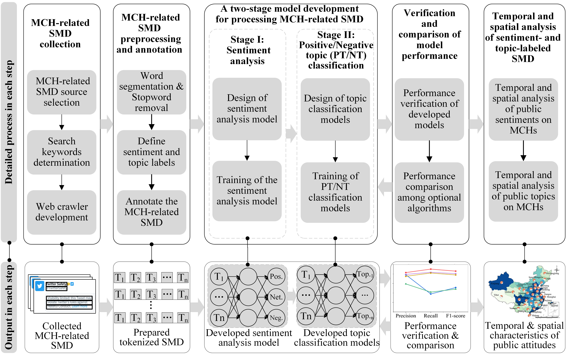

Fig. 1 The MCH-oriented public attitude analysis using SMD

## 3.1 Collecting MCH-related SMD

The process of social media data (SMD) collection encompasses selecting an SMD source, determining search keywords, and developing a web crawler (Fig. 1) (Omar & Ibrahim, 2021). The selection of data sources is contingent on the geographic area and the prevalent social media platform used by the target region’s population. For instance, Weibo, the leading social media platform in Mainland China, provides the context, timestamp, and geolocation of user posts, making it an ideal source for acquiring the desired MCH-related SMD. Subsequently, the initial list of search keywords is generated via brainstorming, forming a wordlist pertinent to MCHs, which is further refined upon reviewing the retrieved SMD (Müller et al., 2023). Determining the search keywords is an iterative process, involving continual refinement and adjustment (Yan et al., 2024). Finally, a web crawler is to be developed, utilizing the official API to legally and autonomously collect a significant volume of data from the social media platform.

## 3.2 Preprocessing and annotating collected SMD

The MCH-related SMD preprocessing involves word segmentation and stopword removal (Fig. 1). Initially, the collected SMD undergoes segmentation, which breaks down the text into discrete tokens (Salau et al., 2023). Subsequently, stopwords will be removed to enhance natural language processing efficiency by utilizing recognized stopword lists (Bedi & Toshniwal, 2022). For example, both word segmentation and stopword removal could be carried out using the Python library such as Jieba commonly used for Chinese text (Zhou et al., 2022).

The SMD annotation includes defining sentiment and topic labels, as well as manually conducting annotation works. Sentiment labels are consistently designated as positive, negative, or neutral, regardless of the research questions. Topic labels, in contrast, should be custom-fitted to the research question, and it is essential to devise MCH-related topic labels based on existing literature (Table 2) and expert insights (Table S1). Table 2 summarizes three primary topic categories pertaining to MCHs, including (i) treatment effects (TE), (ii) administration management (AM), and (iii) facility management (FM). The three categories cover 14 specific topics (Table 2), which include 6 positive topics (e.g., TE-PT1: positive treatment effect) and 8 negative topics (e.g., FM-NT5: high cost).

Table 2 MCH-related positive/negative topic labels

| No. | Topic categories | Sentiments | Codes | Topic labels | Explanations | Examples (Translations of Weibo posts in Chinese) | References |
| --- | --- | --- | --- | --- | --- | --- | --- |
| 1 | Treatment effect (TE) | Positive topics (PTs) on treatment effect | TE-PT1 | Positive treatment effect | Positive effects that are attributed to the medical interventions and care provided within these MCHs. | This approach is more effective than self-isolating at home, preventing further infections within the family. | Zhong et al., 2022; Wang et al., 2020 |
| 2 | TE-PT2 | Trust in experts | Trust in experts and professionals enhances public trust in the treatments available at MCHs. | Academician Wang Chen’s suggestion for the establishment of mobile cabin hospitals marks a pivotal moment. Sound decisions have saved numerous lives. | Gu & Feng, 2022; Huang et al., 2022 |
| 3 | Negative topics (NTs) on treatment effect | TE-NT1 | Negative treatment effect | Negative consequences associated with medical treatments in the MCHs. | A 7-month-old baby in the MCH has a high fever and needs medical attention. Requesting a transfer to a parent-child shelter or a facility with treatment capabilities! Please assist! | Zhong et al., 2022; Kim et al., 2023 |
| 4 | TE-NT2 | Enhanced infection risk | Elevated potential for contracting infections within the MCH environment. | Are there plans for dealing with cross-infections? Are you aiming to further spread it in the community upon departure, sustaining the need for nucleic acid tests and mobile cabins? | Li et al., 2023 |
| 5 | Administrationmanagement (AM) | Positive topics on administration management | AM-PT3 | Effective epidemic control | The Chinese government’s prompt and effective response to Covid-19 has received positive assessments from some quarters. | Within 10 hours, mobile cabin hospitals were built, displaying China’s remarkable speed. The deployment of 42,600 medical personnel to Hubei reflects China’s solidarity during the crisis. | Rothstein et al., 2022; Rahman et al., 2023 |
| 6 | AM-PT4 | Trust in the government | Certain people express strong trust and support for government-led initiatives, including MCHs. | Those who experienced the Yangtze River floods in 1998 will forever appreciate China’s rescue and relief efforts. | Gozgor, 2022; Huang et al., 2022 |
| 7 | Negative topics on administration management | AM-NT3 | Excessive epidemic control measures | Some governmental policies aimed at epidemic control have been criticized for their “one-size-fits-all” approach. | This is bordering on being a concentration camp. | Rothstein et al., 2022; Rahman et al., 2023; Wilson & Flahault, 2023 |
| 8 | AM-NT4 | Lack of trust in the government | Skepticism toward the government has led some to question the efficacy and necessity of all measures, including MCHs. | So, the government doesn’t care at all? Just send them to the MCH as soon as possible, right? They’re all scammers. | Gozgor, 2022 |
| 9 | Facility management (FM) | Positive topics on facility management | FM-PT5 | Dedication of MCH-related workers | Exceptional commitment exhibited by MCH staff, such as doctors, nurses, and volunteers. | Thanks to everyone for their hard work. Together, we will defeat the virus. | Kim et al., 2023; Zhu et al., 2023 |
| 10 | FM-PT6 | Ample medical and living supplies | The MCHs are well-equipped, both medically and in terms of living essentials. | The current situation in Shanghai suggests ample supplies in warehouses and abundant materials for centralized quarantine, fostering a harmonious environment. | Chen et al., 2020; Li et al., 2023; Zhu et al., 2023 |
| 11 | Negative topics on facility management | FM-NT5 | High cost | High construction and operation costs. | Still about money: mobile cabins are not hospitals. Guang’an? How many people live there? Why is it so large? | Li et al., 2023 |
| 12 | FM-NT6 | Lack of privacy | Concerns about reduced personal space within MCHs, as well as public disclosure of personal information related to infections. | In order to protect privacy, women can only use bed sheets to encircle the bed. | Chen et al., 2020; Zhong et al., 2022 |
| 13 | FM-NT7 | Poor medical and living conditions | Criticisms of inadequate provisions in MCHs, including the shortage of living supplies, the lack of recreational amenities, and the insufficient medical staffing. | Is there a black hole over Hubei? Didn’t Governor Wang Xiaodong of Hubei say that there was sufficient supplies? | Kim et al., 2023; Li et al., 2023 |
| 14 | FM-NT8 | Inappropriate site selection | Poorly selected locations that may elevate infection risks or impede effective public health responses. | How were the sites for MCHs selected? Why does the official response lack convincing explanations concerning missing approvals and proximity to residential areas and schools? | Shi et al., 2022 |
| 15 | Unspecified topic (UT) | Unspecified positive SMD | UT-PT7 | Unspecified  praise | General commendations that are not specifically attributed to any feature of MCHs. | I’m moved by this and wish to stay in a mobile cabin hospital. | **/** |
| 16 | Unspecified negative SMD | UT-NT9 | Unspecified complaint | General criticisms that are not particularly directed at any feature of MCHs. | Are you talking nonsense again? | **/** |

All topic labels sourced from the literature (Table 2) undergo confirmation by experts listed in Table S1. After defining annotation labels, SMD will be manually annotated with sentiments (positive, negative, and neutral) and MCH-related topic labels (Table 2) in a back-to-back manner. The preprocessed and annotated SMD texts, complemented by publication timestamps and posting locations, will form a dataset ready for later model development.

## 3.3 Developing the two-stage SMD-based public attitudes analysis model toward MCHs

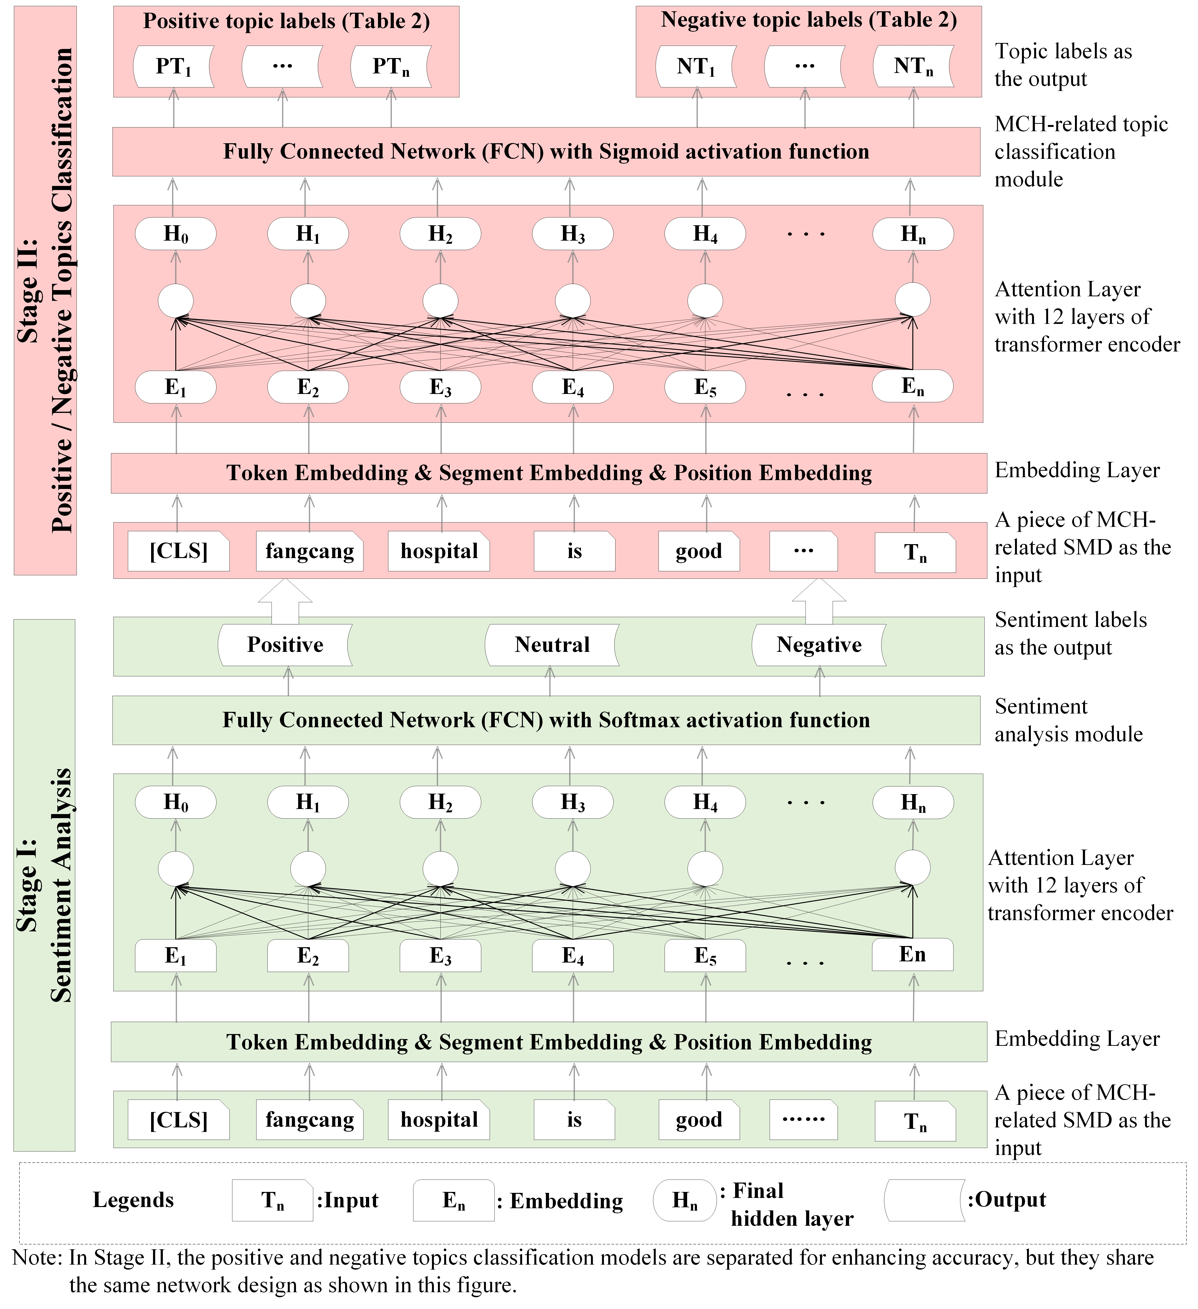

Fig. 2 The two-stage model for mining public attitudes from MCH-related SMD

The model for mining public attitudes from SMD comprises two main stages (Fig. 2). The initial stage focuses on sentiment analysis, followed closely by the second stage of topic classification. The development of both sentiment analysis and topic classification models involves (i) the model design and (ii) the model training.

### 3.3.1 Designing sentiment analysis model for MCH-related SMD

The sentiment analysis aims to classify each MCH-related SMD as positive, neutral, or negative (Fig. 2). The raw SMD serves as the input, with the output being a straightforward label signifying its positive, neutral, or negative sentiment. The model structure consists of the initial Bert component and a trinary classification module (Fig. 2). Specifically, the textual data is tokenized, and the tokenized input passes through an embedding layer. In this embedding layer, each word is encoded as a vector using token embedding, position embedding, and segment embedding (Fig. 2). These embeddings capture the contextual relationships between words, thereby enhancing the model’s understanding of the input SMD (Jamil et al., 2022). Following the embedding layer, the embeddings are processed through the attention layer of the pre-trained BERT, which includes multiple transformer encoder layers (Fig. 2). The attention mechanism facilitates the modeling of long-range dependencies and contextual information (Vaswani et al., 2017; Yadav et al., 2020). The Stage I ends with a custom sentiment analysis module comprising a fully connected FCN layer atop BERT component (Fig. 2).

The topic modeling of MCH-related SMD is approached as a multi-label classification task. Using the sentiment-categorized SMD as input, the Stage II outputs multiple topic labels for each piece of input SMD (Fig. 2). Structurally, this model integrates an initial BERT component with a multi-label classification module, similar to the design of the sentiment analysis stage (Fig. 2). Notably, two classification models for positive and negative topics are trained separately, as the separation could reduce the number of neurons in the output layer, accelerate model fitting, and enhance the model’s accuracy (Müller et al., 2023).

### 3.3.2 Training the sentiment analysis and positive/negative topic classification models

After the model design, both sentiment analysis and topic classification models’ training involve partitioning the dataset, setting crucial training parameters, and scripting the code. The dataset will be partitioned into three distinct subsets in an 80%-10%-10% ratio, i.e., a training set for model learning, a validation set utilized throughout the training phase, and a test set reserved for subsequent model performance verification. The loss function is one of the most important elements during the model training. The loss function of the sentiment analysis model is the sigmoid cross-entropy with logits as exemplified in Eq. 1 where $S$ denotes the set of three sentiment classes, $p_{s}$ is the probability of the input SMD being positive, neutral, and negative class, and the $t_{s}$ is ground truth. Eqs. 2 and 3 correspond to the loss functions for positive and negative topic classifications respectively. $PT$ represents the ensemble of 7 positive topics, whereas $NT$ encompasses the array of 9 negative topics (Table 2). The raw codes including training parameters (e.g., learning rate, batch size, epoch, and drop-out rate) are available in the supplementary materials.

$Loss I= -\sum_{s}^{S}{t_{s}}\log\left(p_{s}\right)$ Eq. 1

$Loss II= -\sum_{pt}^{PT}{t_{pt}}\log\left(p_{pt}\right)$ Eq. 2

$Loss III= -\sum_{nt}^{NT}{t_{nt}}\log\left(p_{nt}\right)$ Eq. 3

## 3.4 Verification and comparison of the two-stage models’ performance

Precision, recall, and F1-score serve as evaluation metrics (Fig. 1) for sentiment analysis and positive/negative topic classification models (Yang et al., 2023). Precision (Eq. 4) quantifies the ratio of true positive predictions (TP) to all positive predictions made (TP & FP). Recall (Eq. 5) captures the fraction of true positives (TP) from all actual positive instances (TP & FN). The F1-score (Eq. 6), as the harmonic mean of precision and recall, offers a comprehensive measure of model performance.

$Precision=\frac{TP}{TP+FP} ×100\%$ Eq. 4

$Recall=\frac{TP}{TP+FN}×100\%$ Eq. 5

$F1-score=\frac{2×Precision×Recall}{\left(Precision+Recall\right)}$ Eq. 6

Beyond the traditional verification metrics (Eqs. 4, 5, and 6), this research will compare the devised model (Fig. 2) against widely-adopted deep learning algorithms, including TextCNN, TextRNN, TextRCNN, and Capsule Net, to ascertain the efficacy of the “Bert+FCN” structure design in Fig. 2. While current literature offers insights into the potential applicability of these algorithms, it’s imprudent to select one algorithm over another without considering the specific context or task at hand (Zhou et al., 2022). Should the performance of the primary algorithm (e.g., Bert) fall short of expectations, the best-performing alternative algorithm can be exploited in the two-stage process (Fig. 2).

## 3.5 Temporal and spatial statistical analysis of public sentiments and topics toward MCHs

The analysis of public sentiments toward MCHs involves the volumes and proportions of sentiment-labeled SMD over time and across regions (Fig. 1). The timestamped nature of each SMD allows tracking sentiment trends with time, and SMD with location tags can uncover the spatial disparities in public sentiments. Besides that, the methods like Pearson correlation test are exploited to investigate the correlations between positive/negative sentiment-labeled SMD and the number of Covid-19 cases (NoCC).

After the sentiment analysis, the study will statistically assess the volumes and rankings of tempo-spatial SMD with specific topic labels, examining the relationship between topic-labeled SMD and NoCC (Fig. 1). This involves using Spearman’s rank correlation test to assess the correlation among quarterly and regional rankings of public topics, K-means clustering to identify quarters and regions with similar public-concerned topics, and a paired T-test to confirm NoCC disparities across clusters. The exploited statistical methods are tailored to the specific research questions for accommodating the data particularities (Chen et al., 2020; Yoo et al., 2020). The tool exploited for all statistics work is SPSS Statistics 27.0.



Fig. 3 Implementation of the methodology for revealing public attitudes toward MCHs in China

# 4. The case study of public attitudes toward MCHs in Mainland China

## 4.1. The implementation of the proposed methodology

The entire process of collecting, processing, and mining MCH-related SMD is illustrated in Fig. 3. The 413572 pieces of raw data are firstly collected using a set of keywords (e.g., Fangcang Hospital) and then processed by word segmentation and the removal of stopwords (Table S1). Afterward, sentiment analysis and positive/negative topic classification models are developed using the manually annotated dataset presented in Table 3.

Table 3 Annotated datasets for developing the two-stage model for public attitudes toward MCH

|  |  |  |  |
| --- | --- | --- | --- |
| Code | Datasets for model training | Annotation types | Profiles of annotated dataset |
| Dataset I | Sentiment analysis | Positive, negative, and neutral labels | 41583 Weibo posts  (Table S1) |
| Dataset II | Positive topic classification | 7 types of positive topics in Table 2 | 17854 Weibo posts  (Table S1) |
| Dataset III | Negative topic classification | 9 types of negative topics in Table 2 | 17059 Weibo posts  (Table S1) |

During two-stage model development (Fig. 2), multiple models based on widely-used algorithms (i.e., BERT, TextCNN, TextRNN, TextRCNN, and Capsule Net) are developed and compared (Fig. 4 and Table S2). The BERT-based transfer learning model showcased superior performance (Figs. 4a, 4b, and 4c), affirming its predominance over the other models. With the developed two-stage model, the outputs of public sentiments and topics embedded in each piece of SMD are offered in Table S1.







Fig. 4 Performance comparison of multiple models in sentiment analysis and positive/negative

topic classification

Table 4 Summary of statistical analysis

| Sections | Tested relationships | Used methods |
| --- | --- | --- |
| Section 4.2.1 | * The temporal and spatial correlation between the volumes of positive/negative SMD and NoCC (Tables 5 and 6). | * Pearson correlation test (Tables 5 and 6) |
| * The temporal and spatial correlation between the proportions of positive/negative SMD and NoCC (Tables 5 and 6). | * Pearson correlation test (Tables 5 and 6) |
| Section 4.2.2 | * The temporal and spatial correlation between the volumes of positive/negative topic-labeled SMD and NoCC (Tables 7 and 9). | * Pearson correlation test   (Tables 7 and 9) |
| * The temporal and spatial correlation among the rankings of positive/negative topic-labeled SMD volumes (Figs. 8 and 11). * The clusters of time periods and provincial regions that exhibit similar rankings of public topics (Figs. 9 and 12), the differences in NoCC of different clusters (Table S3), and the concordance of public positive/negative topics’ rankings within individual clusters (Table 8). | * Spearman rank correlation test (Figs. 8 and 11) * K-means clustering (Figs. 9 and 12), Paired T-test (Table S3), and Kendall’s coefficient of concordance test (Table 8) |

Note: The priori tests of exploiting these methods (e.g., the Shapiro-Wilk test for testing data normality before the Pearson correlation test) are available in Table S3. The NoCC data are retrieved from the National Health Commission of PRC (http://www.nhc.gov.cn/xcs/xxgzbd/gzbd_index.shtml).

The statistical analysis (Fig. 3) displays public sentiments and topics over time and across regions, highlighting temporal variations and spatial disparities of public attitudes toward MCHs. Besides, a series of works (Table 4) further reveals the relationship between public attitudes and NoCC, offering insights into the underlying causes of the observed tempo-spatial variations of public attitudes toward MCHs. Notably, the spatial analysis in this work is primarily confined to SMD post Q2 2022, as there is an imbalance in the geographic tagging of SMD before and after Q2 2022 (Table S1). Prior to Q2 2022, only 2.39% of SMD had location tags, aligning with the global average for geotagged posts on social media platforms (Lozano et al., 2017). Post Q2 2022, this proportion increased to 50.92% of SMDs having geographic tags, due to China’s IP display policy enabling spatial analysis that was challenging to achieve in previous SMD-based studies (Liang et al., 2021).

## 4.2. Results of tempo-spatial analysis of public attitudes toward MCHs

### 4.2.1 Public sentiments toward MCHs

#### (1) Temporal variations of public sentiments toward MCHs

The volumes of SMD on both positive and negative sentiments show temporal variations (Fig. 5), exhibiting a “dual-peak pattern” with surges initially in Q1 2020 and lastly in Q4 2022. The initial peak in Q1 2020, marked by 53% positive sentiments, coincided with the pandemic’s onset. A contrasting second peak in Q4 2022 featured 56% negative sentiments pre-dating the end of MCH policies. Such an observation (Fig. 5) challenges the validity of prior research (Table 1) that narrowly focused on short-term public sentiments, which neglects the temporal evolution of public sentiments. The specific values of the number of positive, negative, and neutral SMD in each quarter are available in Table S3.



Fig. 5 Time-varying volumes and proportions of public sentiments toward MCHs during MCH policy lifecycle

Investigating the potential reason for temporal fluctuations of public sentiments toward MCHs, it is found that the volume and proportions of public sentiments both show significant correlations with NoCC (Table 5). As NoCC rises, a volume uptick is observed in both positive (PCC=0.57) and negative sentiments (PCC=0.85) within the population. The proportion of negative sentiments is directly correlated with NoCC (PCC=0.56), whereas the proportion of positive sentiments is inversely correlated with NoCC (PCC=-0.49). This implies that as the NoCC increases, the rate of amplification in negative sentiments is substantially more pronounced than that in positive sentiments.

Table 5 Temporal correlations between positive/negative sentiments and quarterly NoCC

|  |  |  |  |  |  |
| --- | --- | --- | --- | --- | --- |
| Indicators | | Quarterly volumes of positive SMD | Quarterly volumes of negative SMD | Quarterly proportions of positive SMD | Quarterly proportions of negative SMD |
| Mean | | 13531.92 | 13038.62 | 43.63% | 38.79% |
| Std. Deviation | | 13070.03 | 14306.39 | 9.10% | 9.63% |
| Quarterly NoCC | Pearson Correlation Coefficient (PCC) | 0.57** | 0.85*** | -0.49* | 0.56** |
| Sig. (2-tailed) | 0.04 | 0.00 | 0.09 | 0.05 |

Note: ***, **, and * denote significance at the 1%, 5%, and 10% levels respectively.

#### (2) Spatial variations of public sentiments toward MCHs

The volumes and proportions of positive and negative sentiments vary among different provincial regions during the Covid-19 (Fig. 6). The proportions of positive SMD range from 22.47% (Shanghai) to 47.92% (Jilin), while the proportions of negative SMD range from 48.47% (Shaanxi) to 70.88% (Xinjiang), as detailed in Table S3. This indicates that traditional studies (Table 1) focusing solely on small geographic scopes to gauge public attitudes toward MCHs may overlook regional differences. The specific values of the number of positive, negative, and neutral SMD in each province are available in Table S3.





Fig. 6 Proportions of public sentiments across different regions

The volumes and proportions of public sentiments across regions show significant correlations with regional NoCC (Fig. 6b and Table 6). Both the volumes of SMD with positive (PCC=0.66) and negative (PCC=0.66) sentiments are greater in areas with larger NoCC. Besides, the regional positive SMD proportion is inversely correlated with regional NoCC (PCC=-0.35), while the regional negative SMD proportion exhibits a direct correlation with regional NoCC (PCC=0.31). This further suggests that in regions where the NoCC is high, there is greater public focus on negative concerns than positive ones.

Table 6 Spatial correlations between positive/negative sentiments and regional NoCC

|  |  |  |  |  |  |
| --- | --- | --- | --- | --- | --- |
| Indicators | | Regional positive SMD volumes | Regional negative SMD volumes | Regional positive SMD proportions | Regional negative SMD proportions |
| Mean | | 916.84 | 1872.35 | 34.70% | 59.85% |
| Std. Deviation | | 569.02 | 1688.43 | 6.66% | 6.27% |
| Regional NoCC | Pearson Correlation Coefficient (PCC) | 0.66*** | 0.66*** | -0.35** | 0.31* |
| Sig. (2-tailed) | 0.00 | 0.00 | 0.05 | 0.09 |

### 4.2.2 Public-concerned topics underlying the sentiments

#### (1) Temporal variations of public-concerned topics toward MCHs

The number of SMD regarding all 14 positive or negative topics in treatment effects (Fig. 7a), administration management (Fig. 7b), and facility management (Fig. 7c) exhibit variations over time. The results (Fig. 7) reveal the temporal variety of public concerns on different topics and indicate the shortage of existing studies (Table 1) that are limited to a short term. In topics pertaining to treatment effects and facility management, public concerns are more frequently centered on positive topics (Fig. 7d and 7f) rather than negative ones (Fig. 7g and 7i). Conversely, negative topics (Fig. 7h) consistently outweigh positive ones (Fig. 7e) in discussions related to administration management. The quantity of SMD across all 14 positive or negative topics correlates positively with the quarterly fluctuations in NoCC (Table 7). It is concluded that the level of public concern on each topic varies as the Covid-19 pandemic progresses.



Fig. 7 Temporal variations of positive/negative topic-labeled SMD volumes

Table 7 Correlations between topic-labeled SMD volume and quarterly NoCC

|  |  |  |  |  |  |  |  |  |  |  |  |  |  |  |  |  |  |  |
| --- | --- | --- | --- | --- | --- | --- | --- | --- | --- | --- | --- | --- | --- | --- | --- | --- | --- | --- |
| Positive and negative topics | | TE  (Treatment effect) | | | | | AM  (Administration management) | | | | | FM  (Facility management) | | | | | | |
| TE-PT | | | TE-NT | | AM-PT | | AM-NT | | | FM-PT | | | FM-NT | | | |
| TE-PT1 | TE-PT2 | TE-NT3 | | TE-NT4 | AM-PT5 | AM-PT6 | | AM-NT7 | AM-NT8 | FM-PT9 | FM-PT10 | FM-PT11 | | FM-PT12 | FM-PT13 | FM-PT14 |
| Mean | | 1064.46 | 663.77 | 315.77 | | 180.00 | 667.85 | 378.92 | | 1016.46 | 7715.85 | 883.46 | 183.46 | 432.46 | | 154.62 | 273.31 | 61.46 |
| NoCC | PCC | 0.74*** | 0.75*** | 0.82*** | | 0.89*** | 0.76*** | 0.84*** | | 0.90*** | 0.81*** | 0.65** | 0.79*** | 0.90*** | | 0.70*** | 0.55** | 0.91*** |
| Sig. | 0.00 | 0.00 | 0.00 | | 0.00 | 0.00 | 0.00 | | 0.00 | 0.00 | 0.02 | 0.00 | 0.00 | | 0.01 | 0.05 | 0.00 |

The rankings of public concerns on positive topics exhibit low correlation (Fig. 8a). As for positive topics’ rankings with low correlations, K-means clustering analysis reveals two distinct patterns (Fig. 9) in the rankings of positive topics. The quarters with pattern I emphasize micro-level concerns (i.e., TE-PT1: positive treatment effect) with an average NoCC of 80,616 cases, aligning with more severe outbreaks (Fig. 9). In contrast, the quarters displaying pattern II focus on macro-level topics (i.e., AM-PT3: Effective epidemic control) with an average NoCC being 2,920, coinciding with less severe outbreaks (Table 8). The rankings of public concerns on negative topics show a high correlation across different regions (Fig. 8b) and also exhibit a single pattern (Table 8) with high concordance (KCC=0.86). The administration management topics (i.e., AM-NT4: Lack of trust in the government and AM-NT3: Excessive epidemic control measures) carry the greatest influence among those with negative connotations. The discussions of such phenomena are conducted in later Section 5.3.



Fig. 8 Rank correlation among MCH-related (a) positive and (b) negative topics of different time periods

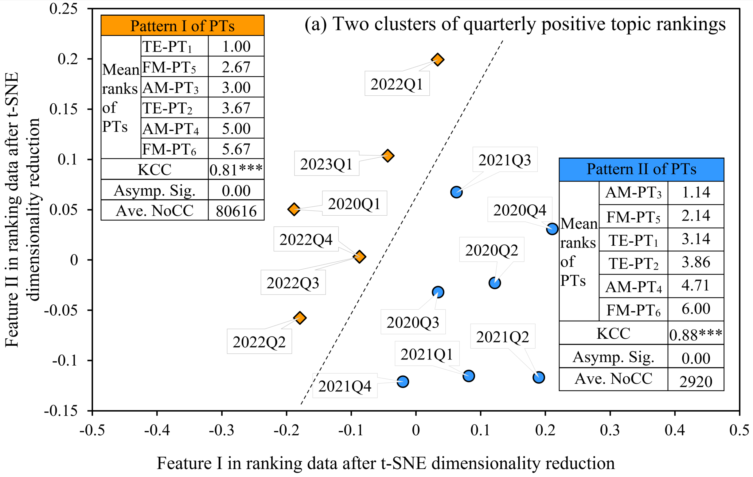

Fig. 9 The time period clusters categorized into two patterns of positive topic rankings

Table 8 Temporal and spatial patterns of public topic rankings

|  |  |  |  |  |
| --- | --- | --- | --- | --- |
| Patterns of public topic rankings | | Pattern I of positive topic rankings | Pattern II of positive topic rankings | Pattern of negative topic rankings |
| Temporal/Spatial public topic rankings, from most to least concerned | | * TE-PT1: Positive treatment effect * FM-PT5: Dedication of MCH-related workers * AM-PT3: Effective epidemic control * TE-PT2: Trust in experts * AM-PT4: Trust in the government * FM-PT6: Ample medical and living supplies | * AM-PT3: Effective epidemic control * FM-PT5: Dedication of MCH-related workers * TE-PT1: Positive treatment effect * TE-PT2: Trust in experts * AM-PT4: Trust in the government * FM-PT6: Ample medical and living supplies | * AM-NT4: Lack of trust in the government * AM-NT3: Excessive epidemic control measures * FM-NT5: High cost * TE-NT1: Negative treatment effect * FM-NT7: Poor medical and living conditions * FM-NT6: Lack of privacy * TE-NT2: Enhanced infection risk * FM-NT8: Inappropriate site selection |
| Concordance test for topic rankings over time | N | 6 quarters (Fig. 9) | 7 quarters (Fig. 9) | 13 quarters |
| KCC | 0.81*** | 0.88*** | 0.86*** |
| Asymp.  Sig. | 0.00 | 0.00 | 0.00 |
| Concordance test for topic ranking across regions | N | 16 regions (Fig. 12) | 15 regions (Fig. 12) | 31 regions |
| KCC | 0.87*** | 0.81*** | 0.90*** |
| Asymp.  Sig. | 0.00 | 0.00 | 0.00 |

Note: KCC refers to Kendall’s Coefficient of Concordance. The explanations of the phenomena are offered in the later section 5.3

#### (2) Spatial variations of public topics toward MCHs

The number of SMD on public topics of treatment effects (Fig. 10a), administration management (Fig. 10b), and (Fig. 10c) show variabilities across 31 regions, indicating that existing research (Table 1) that often concentrates on narrow geographical areas may not fully represent broader public discourse. Furthermore, a higher regional NoCC correlates with increased SMD volumes on all 14 positive or negative topics (Table 9). It suggests that public concerns on all topics correspondingly rise as the severity of the pandemic escalates within a region.







Fig. 10 Spatial disparities of SMD with various topics

Table 9 Correlations between topic-labeled SMD volume and regional NoCC

|  |  |  |  |  |  |  |  |  |  |  |  |  |  |  |  |  |
| --- | --- | --- | --- | --- | --- | --- | --- | --- | --- | --- | --- | --- | --- | --- | --- | --- |
| Positive and negative topics | | TE  (Treatment effect) | | | | AM  (Administration management) | | | | FM  (Facility management) | | | | | | |
| TE-PT | | TE-NT | | AM-PT | | AM-NT | | FM-PT | | | FM-NT | | | |
| TE-PT1 | TE-PT2 | TE-NT3 | TE-NT4 | AM-PT5 | AM-PT6 | AM-NT7 | AM-NT8 | FM-PT9 | FM-PT10 | FM-PT11 | | FM-PT12 | FM-PT13 | FM-PT14 |
| Mean | | 70.55 | 27.16 | 48.23 | 24.42 | 38.81 | 22.42 | 234.94 | 1204.19 | 36.90 | 18.90 | 95.23 | | 41.13 | 45.55 | 22.42 |
| NoCC | PCC | 0.58*** | 0.57*** | 0.79*** | 0.85*** | 0.31* | 0.64*** | 0.36** | 0.63*** | 0.75*** | 0.70*** | 0.86*** | | 0.80*** | 0.77*** | 0.83*** |
| Sig. | 0.00 | 0.00 | 0.00 | 0.00 | 0.09 | 0.00 | 0.05 | 0.00 | 0.00 | 0.00 | 0.00 | | 0.00 | 0.00 | 0.00 |

In the spatial dimension, the rankings of positive topics display regional variability (Fig. 11a), while the rankings of negative topics show regional consistency (Fig. 11b). Specifically, mirroring the temporal patterns observed in positive topics (Table 8), the 31 regions can be broadly categorized into two clusters (Fig. 12). Within each cluster, the rankings of positive topics exhibit a high degree of consistency, with KCC values of 0.87 and 0.81 respectively (Table 8). These two clusters show substantial differences in the NoCC, with an average of 20872 for Pattern I regions and 2445 for Pattern II regions (Fig. 12). Conversely, the rankings of negative topics show a high correlation (Table 8 and Fig. 11b) and demonstrate regional uniformity with a high KCC value of 0.90 (Table 8).





Fig. 11 Correlation analysis of rankings among (a) positive and (b) negative MCH-related topics across regions

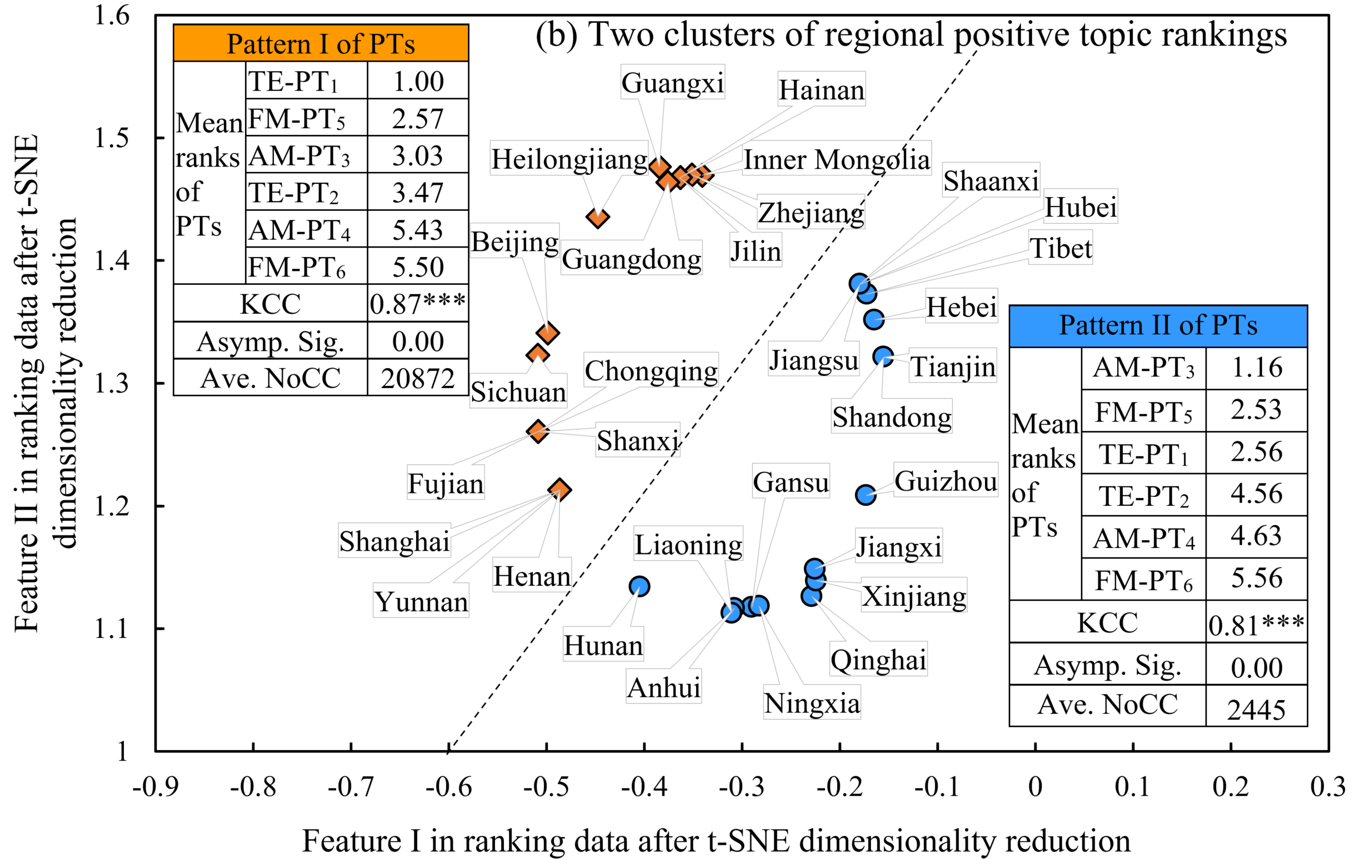

Fig. 12 The clusters of provincial regions categorized into two patterns on positive topic rankings

# 5. Discussion

## 5.1 Contributions of this work

The primary contribution of this work lies in devising an SMD-based approach to uncovering public attitudes toward MCHs. In contrast to conventional survey-based studies (Table 1), this newly devised approach holds three advantages regarding the harness of a massive volume of data (Fig. 3), the freedom from temporal limitations on data collection (Figs. 5 and 7), and the access to border regions (Figs. 6 and 10). Firstly, it capitalizes on the ability to harness a vast volume of user-generated data. This is in stark contrast to traditional methods, which often have limitations in terms of participants’ size (Table 1). Secondly, it is not bound by temporal restrictions on data collection. Unlike traditional research (Table 1), which may have finite timelines and resource constraints, this approach has the flexibility to adapt to evolving public sentiments and topics over time (Figs. 5 and 7). Thirdly, this approach grants access to a diverse range of users across geographical borders (Figs. 6 and 10), making it more representative of the entire population compared to traditional methods that are confined to a small region (Table 1). These unique advantages enable the proposed approach to disclose the dynamic public sentiments concerning MCHs in China (Figs. 5 and 6), identify dominant positive and negative MCH-related topics (Table 8), and reveal the spatial and temporal evolutions of public attitudes along with NoCC (Tables 5, 6, 7, and 9).

In addition to the contribution highlighted earlier, this study offers a comparative analysis of prevalent algorithms used in sentiment analysis and supervised topic classification (Fig. 4), laying the groundwork for future SMD-mining research in algorithm selection. The existing studies on SMD directly choose a certain algorithm, they seldom conduct comparative assessments of the algorithms typically employed for sentiment analysis and topic classification (Tang et al., 2023; Kürtüncü et al., 2023; Gu et al., 2023). The finding (Fig. 4) indicates the superior performance of the “Bert+FCN” structure design (Fig. 2), which can serve as a reference for subsequent research on mining public attitudes from SMD. The performance comparison (Fig. 4) not only identifies which algorithms are more suitable for analyzing public attitudes toward MCH, but also establishs a performance benchmark, together with openly available SMD (Table S1), to facilitate more competitive SMD-mining algorithms in this domain.

## 5.2 Policy implications for improving public attitudes toward MCHs

Based on the critical findings of public attitudes toward MCHs (Fig. 3), this work suggests three principal policy implications for mitigating resistance and fostering positive perceptions during MCH policy implementation. These policy implications include (i) flexible policies tailored to specific temporal and spatial contexts, (ii) prioritization of addressing the most influential MCH-related topics, and (iii) the consideration of the external factor (e.g., NoCC) that significantly shapes public attitudes on MCHs.

These policy implications are specifically presented as follows. Firstly, this study reveals the disparities in public attitudes toward MCHs across different locations and time periods (Figs. 5, 6, 7, and 10). This implies that there is no one-size-fits-all policy to improve public attitudes toward MCHs. Instead, policies should be tailored based on local practices and circumstances. Secondly, this work clarifies the degrees of public concern on different positive and negative topics (Table 8). This can guide the government to allocate more attention and resources toward addressing the topics that have a greater influence on public attitudes. By enhancing positive perceptions and reducing negative emotions of more influencing topics (Table 8), overall public attitudes toward MCHs can be improved in a more efficient manner. Lastly, it is crucial for the government to be aware that the pandemic severity itself can affect public attitudes toward MCHs (Tables 5-9). During times when the outbreak is severe, even effective measures like MCHs may face increased negative sentiments from the public. Therefore, policymakers should factor in the pandemic severity when persisting with, adjusting, or refining MCH-related policies.

## 5.3 Potential explanations of distinct ranking patterns of public topics

During the Covid-19 pandemic, public concerns in positive MCH-related topics (MCH) demonstrated two distinct patterns (Figs. 9 and 12). The explanation of positive topics exhibiting two ranking patterns could utilize Maslow’s Hierarchy of Needs. In areas where the epidemic is less severe (i.e., smaller NoCC), people may feel their basic safety needs are met and thus prioritize macro-effective control (Hou et al., 2021) (i.e., AM-PT3: Effective epidemic control). Conversely, in the region and the time with a severe epidemic (i.e., larger NoCC), the immediate and pressing need for effective treatment aligns with the basic need for health and well-being, thereby shifting the focus to the efficacy of medical interventions (Wilson & Flahault, 2023; Li et al., 2023) (i.e., TE-PT1: positive treatment effect).

Different from positive topics, the rankings of negative MCH-related topics remain steady over time and are almost uniform across regions (Table 8). This may be attributed to the principles of the “Negativity Bias Theory” and the “Attribution Theory”. On the one hand, the “Negativity Bias Theory” posits that psychologically, humans are predisposed to reach a consensus more readily on negative topics than on positive ones, as negative information tends to have a greater impact on a person’s psychological state (Saleska & Choi, 2021). On the other hand, the top two negative topics are concerning administrative management (Table 8). “Attribution Theory” explains how individuals deduce the causes of events, assign blame, and form judgments based on what they observe (Nera et al., 2022; Rahman et al., 2023). This theory reveals a common tendency for people to attribute blame for an issue to the entity with the highest level of control, which, in the context of MCHs, is the government. Since the government is the ultimate authority of MCHs during Covid-19 pandemic, the public may view the government as the issue’s origin and the administrative actions as either inadequate or overly drastic. Consequently, the two negative topics pertaining to administrative management consistently rank at the forefront of negative discussions.

## 5.4 Limitations and further endeavors

This study acknowledges limitations requiring further exploration, including SMD representativeness, locally specific topics, and contextual understanding. Firstly, while leveraging a larger sample size than survey-based approaches (Table 1), this study may not claim a comprehensive representation of all populations due to inherent social media demographic biases. Secondly, although Table 2 offers a reference for MCH-related topics, reapplying the proposed approach (Fig. 1) may require additional topics that hold special relevance to the local population, owing to differences in cultural, economic, and healthcare conditions across nations. Finally, our developed model (Fig. 2), despite its high performance (Fig. 4), still contains errors in contextual understanding. These limitations necessitate further refinement in future research endeavors.

# 6. Conclusion

This study proposes an SMD-based approach to mine public sentiments and topics regarding MCHs for revealing public attitudes toward MCHs, which could be a supplemental approach in public attitude research of MCHs. This approach consists of MCH-related SMD collection, SMD preprocessing, the two-stage model development (i.e., sentiment analysis and topic classification), model performance verification and comparison, and tempo-spatial statistical analysis. This newly proposed approach has been demonstrated for mining 413572 pieces of SMD concerning MCHs in China. The critical findings indicate: (i) Public sentiments, as well as public concerns on MCH-related topics, vary both temporally and spatially; (ii) The proportion of negative sentiments rises with larger NoCC, while the proportion of positivity decreases; and (iii) The rankings of positive topics shift between two patterns with the pandemic severities, while negative topic rankings remain consistent across time and space. The approach overcomes the constraints of respondents, time, and space in conventional survey-based studies (Table 1) that may not fully capture the spatial-temporal dynamics of public attitudes toward MCHs. Moreover, the insights provided by this work can help policymakers in devising MCH-related policies, including encouraging a departure from a one-size-fits-all policy, placing greater focus on influential positive and negative topics, and paying attention to external factors like NoCC.

# Acknowledgment

The authors wish to express sincere gratitude for the financial support from the Hong Kong RGC’s Collaborative Research Fund (No. XXX) and National Natural Science Foundation of China (No. XXX). All supplemental materials including collected SMD, shared codes, and developed models are available in the GitHub repository (<https://github.com/0AnonymousSite0/Mining-Social-Media-Data-for-Revealing-Public-Attitudes-toward-Mobile-Cabin-Hospitals>).

# References

Andreotta, M., Nugroho, R., Hurlstone, M. J., et al. (2019). Analyzing social media data: A mixed-methods framework combining computational and qualitative text analysis. *Behavior Research, 51*(4), 1766-1781.

Bastola, A., Dhital, R., Shah, R., Subedi, M., Hamal, P. K., Shrestha, C., Chalise, B. S., Maharjan, K., Nepal, R., & Rajbhandari, S. (2021). Experiences of COVID-19 patients admitted in a government infectious disease hospital in Nepal and its implications for health system strengthening: A qualitative study. *PloS one*, *16*(12), e0261524.

Bedi, J., Toshniwal, D. (2022). CitEnergy: A BERT based model to analyze Citizens’ Energy-Tweets. *Sustainable Cities and Society, 80*, 103706.

Blei, D. M., Ng, A. Y., & Jordan, M. I. (2003). Latent dirichlet allocation. *Journal of machine Learning research*, *3*(Jan), 993-1022.

Byrne, M., O’Malley, L., Glenny, A. M., Pretty, I., & Tickle, M. (2021). Assessing the reliability of automatic sentiment analysis tools on rating the sentiment of reviews of NHS dental practices in England. *Plos one*, *16*(12), e0259797.

Chen, S., Zhang, Z., Yang, J., Wang, J., Zhai, X., Bärnighausen, T., & Wang, C. (2020). Fangcang shelter hospitals: a novel concept for responding to public health emergencies. *Lancet (London, England)*, *395*(10232), 1305–1314.

Goei, A., & Mohan Tiruchittampalam, Grad Dip Healthcare Management & Leadership, FRCS (A&E) (2020). Community Care Facility-A Novel Concept to Deal With the COVID-19 Pandemic: A Singaporean Institution's Experience. *Journal of public health management and practice : JPHMP*, *26*(6), 613–621.

Gozgor G. (2022). Global Evidence on the Determinants of Public Trust in Governments during the COVID-19. *Applied research in quality of life*, *17*(2), 559–578.

Gu, C., & Feng, Y. (2022). Influence of Public Engagement with Science on Scientific Information Literacy During the COVID‑19 Pandemic: Empirical Evidence from College Students in China. *Science & education*, *31*(3), 619–633.

Gu, L., Liu, F., Wang, J., Li, J., Wei, J., & Xu, J. (2023). Stress load and volunteer motivation of patient volunteers in Fangcang shelter hospitals in Shanghai, China during the COVID-19 pandemic: a cross-sectional survey. *BMJ open*, *13*(4), e066930.

Gu, Y., Zhu, Y., & Xu, G. (2022). Factors associated with mental health outcomes among health care workers in the Fangcang shelter hospital in China. *The International journal of social psychiatry*, *68*(1), 64–72.

Hodorog, A., Petri, I., Rezgui, Y. (2022). Machine learning and Natural Language Processing of social media data for event detection in smart cities. *Sustainable Cities and Society, 85*, 104026.

Hou, K., Hou, T., & Cai, L. (2021). Public attention about COVID-19 on social media: An investigation based on data mining and text analysis. *Personality and Individual Differences*, 175, 110701.

Huang, A., Gallegos, L., & Lerman, K. (2017). Travel analytics: Understanding how destination choice and business clusters are connected based on social media data. *Transportation Research Part C: Emerging Technologies*, 77, 245-256.

Huang, Y. H. C., Li, J., Liu, R., & Liu, Y. (2022). Go for zero tolerance: Cultural values, trust, and acceptance of zero-COVID policy in two Chinese societies. *Frontiers in Psychology, 13*.

Hussein, D. M. E. M. (2018). A survey on sentiment analysis challenges. *Journal of King Saud University - Engineering Sciences*, 30(4), 330-338.

Jamil, M. L., Pais, S., Cordeiro, J., et al. (2022). Detection of extreme sentiments on social networks with BERT. *Social Network Analysis and Mining*, 12(1), 55.

Kanu, S., James, P. B., Bah, A. J., Kabba, J. A., Kamara, M. S., Williams, C. E. E., & Kanu, J. S. (2021). Healthcare Workers' Knowledge, Attitude, Practice and Perceived Health Facility Preparedness Regarding COVID-19 in Sierra Leone. *Journal of multidisciplinary healthcare*, *14*, 67–80.

Kim, Y., Shin, J. M., Yoo, S. H., & Keam, B. (2023). Challenges in Care for Non-COVID-19 Patients with Severe Chronic Illnesses during COVID-19 Pandemic: A Qualitative Study of Healthcare Providers Working around Acute Care Hospitals in South Korea. *Healthcare (Basel, Switzerland)*, *11*(4), 611.

Kürtüncü, M., Kurt, A., & Arslan, N. (2023). The Experiences of COVID-19 Patients in Intensive Care Units: A Qualitative Study. *OMEGA - Journal of Death and Dying*, 87(2), 504–518.

Levy, N., Zucco, L., Ehrlichman, R. J., Hirschberg, R. E., Hutton Johnson, S., Yaffe, M. B., ... & Leibowitz, A. (2020). Development of rapid response capabilities in a large COVID-19 alternate care site using failure modes and effect analysis with in situ simulation. *Anesthesiology*, *133*(5), 985-996.

Li, F., Yigitcanlar, T., Nepal, M., Nguyen, K., Dur, F. (2023). Machine learning and remote sensing integration for leveraging urban sustainability: A review and framework. *Sustainable Cities and Society, 96*, 104653.

Li, G., Du, H., Fan, J., He, X., & Wang, W. (2023). The Effect of Fangcang Shelter Hospitals under Resource Constraints on the Spread of Epidemics. *International journal of environmental research and public health*, *20*(10), 5802.

Liang Q, Hu C, Chen S. Evaluation of the Optimal Topic Classification for Social Media Data Combined with Text Semantics: A Case Study of Public Opinion Analysis Related to COVID-19 with Microblogs. *ISPRS International Journal of Geo-Information*. 2021; 10(12):811.

Lou, X., Liu, P., Xie, Z., & Li, D. (2023). Public perceptions on the policy of electronic cigarettes as medical products on Twitter. *International Journal of Environmental Research and Public Health*, 20(3), 2618.

Lozano, M., Schreiber, J., & Brynielsson, J. (2017). Tracking geographical locations using a geo-aware topic model for analyzing social media data. *Decision Support Systems*, 99, 18-29.

Mcauliffe, J., & Blei, D. (2007). Supervised topic models. *Advances in neural information processing systems*, *20*.

Mohan, G.B., Kumar, R.P. (2022). A Comprehensive Survey on Topic Modeling in Text Summarization. In: Sharma, D.K., Peng, SL., Sharma, R., Zaitsev, D.A. (eds) Micro-Electronics and Telecommunication Engineering . ICMETE 2021. Lecture Notes in Networks and Systems, vol 373. Springer, Singapore.

Müller, Martin; Salathé, Marcel; Kummervold, Per E. (2023). COVID-Twitter-BERT: A natural language processing model to analyze COVID-19 content on Twitter. Frontiers in Artificial Intelligence, 6, 2023.

Nera, K., Bertin, P., & Klein, O. (2022). Conspiracy theories as opportunistic attributions of power. *Current Opinion in Psychology*, 47, 101381.

Omar, A., & Ibrahim, W. (2021). A Sentiment Analysis of Egypt’s New Real Estate Registration Law on Facebook. *International Journal of Advanced Computer Science and Applications, 12*.

Park, J. Y., Mistur, E., Kim, D., Mo, Y., Hoefer, R. (2022). Toward human-centric urban infrastructure: Text mining for social media data to identify the public perception of COVID-19 policy in transportation hubs. *Sustainable Cities and Society, 76*, 103524.

Pavlinek, M., & Podgorelec, V. (2017). Text classification method based on self-training and LDA topic models. *Expert Systems with Applications, 80*, 83-93.

Rahman, M. M., Khan, N. I., Sarker, I. H., Ahmed, M., & Islam, M. N. (2023). Leveraging machine learning to analyze sentiment from COVID-19 tweets: A global perspective. *Engineering Reports*, 5(3), e12572.

Rothstein, H., Demeritt, D., Paul, R., & Wang, L. (2022). True to Type? How Governance Traditions Shaped Responses to Covid-19 in China, Germany, UK, and USA. In Covid-19 and the Sociology of Risk and Uncertainty: Studies of Social Phenomena and Social Theory Across 6 Continents (pp. 115-143). Cham: Springer International Publishing.

Roy, P. K., Kumar, A., Singh, J. P., Dwivedi, Y. K., Rana, N. P., Raman, R. (2021). Disaster related social media content processing for sustainable cities. *Sustainable Cities and Society, 75*, 103363.

Salau, A.O., Omojola, T.O., & Oke, W.A. (2023). Sentiment Analysis of Public Health Concerns of Tokyo 2020 Olympics Using LSTM. In S. Jain, S. Groppe, & B.K. Bhargava (Eds.), Semantic Intelligence. Lecture Notes in Electrical Engineering, Vol. 964. Springer, Singapore.

Saleska, J. L., Choi, K. R. (2021). A behavioral economics perspective on the COVID-19 vaccine amid public mistrust. *Translational Behavioral Medicine, 11*(3), 821–825.

Shi, F., Li, H., Liu, R., Liu, Y., Liu, X., Wen, H., & Yu, C. (2022). Emergency preparedness and management of mobile cabin hospitals in China during the COVID-19 pandemic. *Frontiers in Public Health*, *9*, 763723.

Sun, H., Wang, S., Wang, W., Han, G., Liu, Z., Wu, Q., & Pang, X. (2021). Correlation between emotional intelligence and negative emotions of front‐line nurses during the COVID‐19 epidemic: A cross‐sectional study. *Journal of clinical nursing*, *30*(3-4), 385-396.

Sun, M., Zhao, X., Lin, J., Jing, J., Wang, D., & Jia, G. (2022). PSLDA: A novel supervised pseudo document-based topic model for short texts. *Frontiers of Computer Science, 16*(6), 2095-2228.

Tang, X., Lu, J., Chen, Z., Liu, C., Jiang, X., & Ning, M. (2023). Influencing Factors of Patients’ Trust in Nurses During the COVID-19 Pandemic: A Mixed-Methods Study. *Disaster Medicine and Public Health Preparedness,* *17*, E302.

Tran, T., Ba, H., & Huynh, V. N. (2019). Measuring hotel review sentiment: An aspect-based sentiment analysis approach. In *Integrated Uncertainty in Knowledge Modelling and Decision Making: 7th International Symposium, IUKM 2019, Nara, Japan, March 27–29, 2019, Proceedings 7* (pp. 393-405). Springer International Publishing.

Vaswani, A., Shazeer, N., Parmar, N., Uszkoreit, J., Jones, L., Gomez, A. N., ... & Polosukhin, I. (2017). Attention is all you need. *Advances in neural information processing systems*, *30*.

Wang, K., Gao, J., Song, X., Huang, J., Wang, H., Wu, X., Yuan, Q., Li, X., Cheng, F., Cheng, Y. (2020). Fangcang shelter hospitals are a One Health approach for responding to the COVID-19 outbreak in Wuhan, China. *One Health, 10*, 100167.

Wilson, O., & Flahault, A. (2023). China’s U-turn in its COVID-19 policy. *Anaesthesia Critical Care & Pain Medicine, 42*(2), 101197.

Wu, C., Yan, J., He, C., Wu, J., Zhang, Y., Du, J., Lin, Y., Zhang, Y., Heng, C., & Lang, H. (2022). Latent profile analysis of security among patients with COVID-19 infection in mobile cabin hospitals and its relationship with psychological capital. *Frontiers in Public Health, 10*.

Wu, H., Liao, K., Yang, C., et al. (2022). Psychological experience of juvenile patients’ parents in Fangcang shelter hospital during the Omicron wave of COVID-19 pandemic in Shanghai, China: A qualitative study. *BMC Public Health*, 22, 2203.

Wu, Y., Xi, S., Yao, Y., Xu, F., Tong, H., & Lu, J. (2018). Guiding supervised topic modeling for content-based tag recommendation. *Neurocomputing, 314*, 479-489.

Xie, T., Ge, Y., Xu, Q., & Chen, S. (2023). Public Awareness and Sentiment Analysis of COVID-Related Discussions Using BERT-Based Infoveillance. *AI,* 4(1), 333-347.

Yadav, J., Kumar, D., & Chauhan, D. (2020). Cyberbullying detection using pre-trained bert model. In *2020 International Conference on Electronics and Sustainable Communication Systems (ICESC)* (pp. 1096-1100). IEEE.

Yan, Z., Guo, X., Zhao, Z., Tang, L. (2024). Achieving fine-grained urban flood perception and spatio-temporal evolution analysis based on social media. *Sustainable Cities and Society, 101*, 105077.

Yang, K., & Liu, J. (2021). Weibo Sentiment Analysis Based on Advanced Capsule Network. In *Proceedings of the 2021 3rd International Symposium on Computer Science and Intelligent Control (ISCSIC)* (pp. 211-216).

Yang, Y., Zhang, K., & Fan, Y. (2023). sDTM: A Supervised Bayesian Deep Topic Model for Text Analytics. *Information Systems Research*, *34*(1), 137-156.

Yao, F., Wang, Y. (2020). Towards resilient and smart cities: A real-time urban analytical and geo-visual system for social media streaming data. *Sustainable Cities and Society, 63*, 102448.

Yoo, J., Dutra, S.V.O., Fanfan, D., et al. (2020). Comparative analysis of COVID-19 guidelines from six countries: A qualitative study on the US, China, South Korea, the UK, Brazil, and Haiti. *BMC Public Health*, 20, 1853.

Yu, H., Yu, G., Li, Y., & Li, T. (2022). Study on the communication effect of the social livestream of cabin hospitals’ construction process during the COVID-19 outbreak. Frontiers in Public Health, 10, 978970.

Zakaria, A., Isa, N. M., Hairudin, T., & Ismail, H. N. (2021). The satisfaction of the users with the islamic design quality in instant hospitals for non-critical covid-19 patients in malaysia. *Journal of Islamic Thought and Civilization*, 11(1), 355-373.

Zhong, Y., Zhao, H., Lee, T. Y., Yu, T., Liu, M. F., & Ji, J. (2022). Experiences of COVID-19 patients in a Fangcang shelter hospital in China during the first wave of the COVID-19 pandemic: a qualitative descriptive study. *BMJ open*, *12*(9), e065799.

Zhou, S., Ng, S. T., Huang, G., Dao, J., & Li, D. (2022). Extracting interrelated information from road-related social media data. *Advanced Engineering Informatics*, 54, 101780.

Zhu, J., Zhu, G. P., Weng, Y. M., Zhang, Y., & Li, B. X. (2023). Clinical Practice and Effectiveness Analysis of the Management of Corona Virus Disease 2019 Infected at Shanghai Fangcang Shelter Hospital: A Descriptive Study. *Risk management and healthcare policy*, 16, 337–346.

Zhu, R., Ding, Q., Yu, M., Wang, J., & Ma, M. (2021). Early Warning Scheme of COVID-19 related Internet Public Opinion based on RVM-L Model. *Sustainable Cities and Society*, 74, 103141.